February 10, 2006

Dr. Galley started the lecture by doing a demonstration on the overhead projector. He depicted two glycine molecules in solution using two straight arrows. If these two molecules are in solution, there is no orientation of the sample and one therefore cannot differentiate between them. He then used left and right handed helices to represent two alanine molecules (one D and one L) in solution. One can differentiate between these chiral molecules, even in solution, because the two isomers have different screw senses.

The types of experiments we would use for this:
Linear Dichroism looks at the difference between the absorption of plane polarized light in two different directions. The samples must have some orientation (either natural or induced) to see linear dichroism.
Circular Dichroism looks at the difference between the absorption of left and right circularly polarized radiation. Regardless of orientation, any sample in which the molecules have a screw sense will show circular dichroism. What gives rise to circular dichroism? In general, maximum absorption results when the oscillating vector of the radiation lies along the direction of the transition dipole moment. Now consider the case of our alanine molecules, above. Because of the asymmetric centre (the alpha carbon having a methyl group on one hand and a hydrogen on the other) the pi electron cloud is pulled into a helical twist. Depending on whether one is looking at a D or L amino acid the helical twist could be induced in one direction or the other. An electron in this molecule, when excited by radiation, will thus tend to have a helical path associated with it.

Linear Dichroism in DNA:
Consider a pulsed gel electrophoresis experiment in which DNA in solution is oriented due to the presence of an imposed electric field (figure 1). Recall that DNA separation by pulsed gel electrophoresis is based on molecular weight and depends on the fact that DNA tends to align with the field and undergo reptation when the field is on but tends to relax when the field is off. It is the relaxation of the DNA upon removal of the electric field which is dependent upon molecular weight. Separation is thus induced.
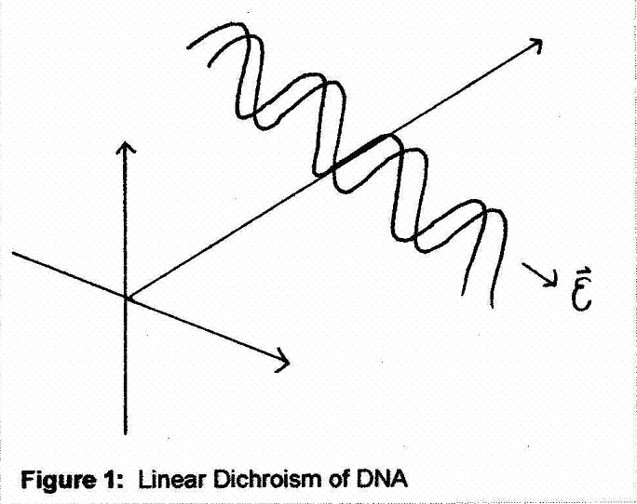
One could follow such an experiment by looking at how the DNA absorbs plane polarized UV radiation (260nm). The dichroic ratio is given by the expression:
DR = (I// - I⊥) / (I// + I⊥)

The aromatic bases will experience Π to Π* transitions in their plane. Since the bases lie approximately perpendicular to the long axis of the DNA, they will preferentially absorb light which is oriented perpendicular to the imposed electric field. Therefore, in this case, one will see a non-zero, negative dichroic ratio.
In the presence of stronger electric field, more alignment will be produced. In most experiments, as the electric field approaches infinity the molecules reach perfect alignment and the dichroic ratio approaches one. However in the case of DNA, extrapolation of the dichroic ratio to infinite electric field reveals that it does not, in fact, go to one. This is proof of the fact that the bases in dsDNA are not perfectly parallel to one another; there is a twist to them. The Π electrons are thus not exactly perpendicular to the long axis of the DNA.

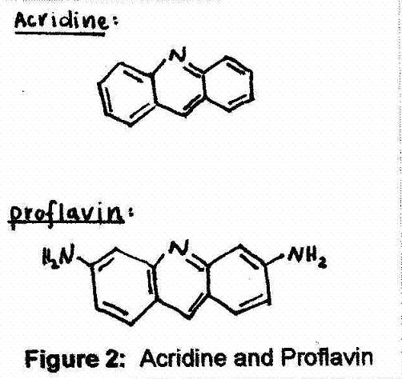
Linear dichroism can also be used to study how chromophores which absorb independently of DNA bind to it. Consider the planar chromophores acridine and proflavin (figure 2) which absorb in the visible part of the spectrum around 500nm (conveniently removed from the absorption range of DNA). The electrons in these chromophores will undergo Π to Π* transitions in the plane of the molecule upon excitation.
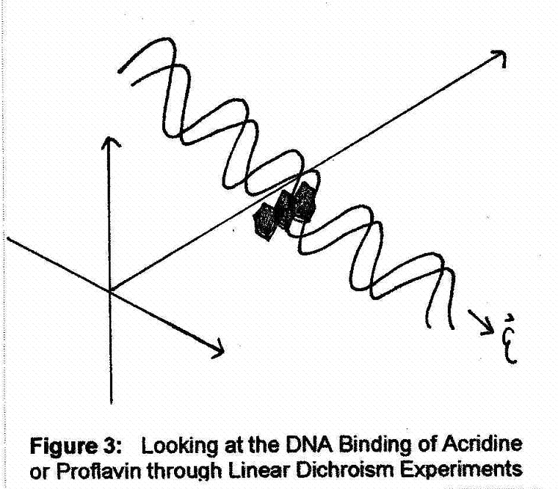
Now, one can orient a DNA sample (by flow or by electric field) in the presence of proflavin and look at the dichroic ratio again. One can measure the absorbance at either 500nm (proflavin) or at 260nm (DNA bases). Note that these molecules do absorb some radiation at 260nm, but if the ratio of proflavin to DNA bases is small the absorbance at this wavelength will be dominated by the DNA. Looking at the oriented sample one finds that the dichroic ratio for proflavin-bound DNA (A₅₀₀) has the same sign as for the DNA by itself (A₂₆₀), suggesting that the proflavin molecules tend to be coplanar with the DNA bases. This provides evidence that the molecules are intercalating or binding between the DNA bases (figure 3). Consistent with the idea of intercalation, is the fact that when looking at A₂₆₀, the dichroic ratio is somewhat larger for the proflavin-bound DNA than for DNA by itself. This phenomenon may be explained by the hypothesis that intercalation causes untwisting and stiffening of the DNA so that the alignment of the bases is higher in the case of the proflavin bound DNA than it is for DNA by itself. For other DNA binding molecules one may find dichroic ratios that are not at all consistent with the idea of intercalation.

Linear Dichroism in Polypeptides:
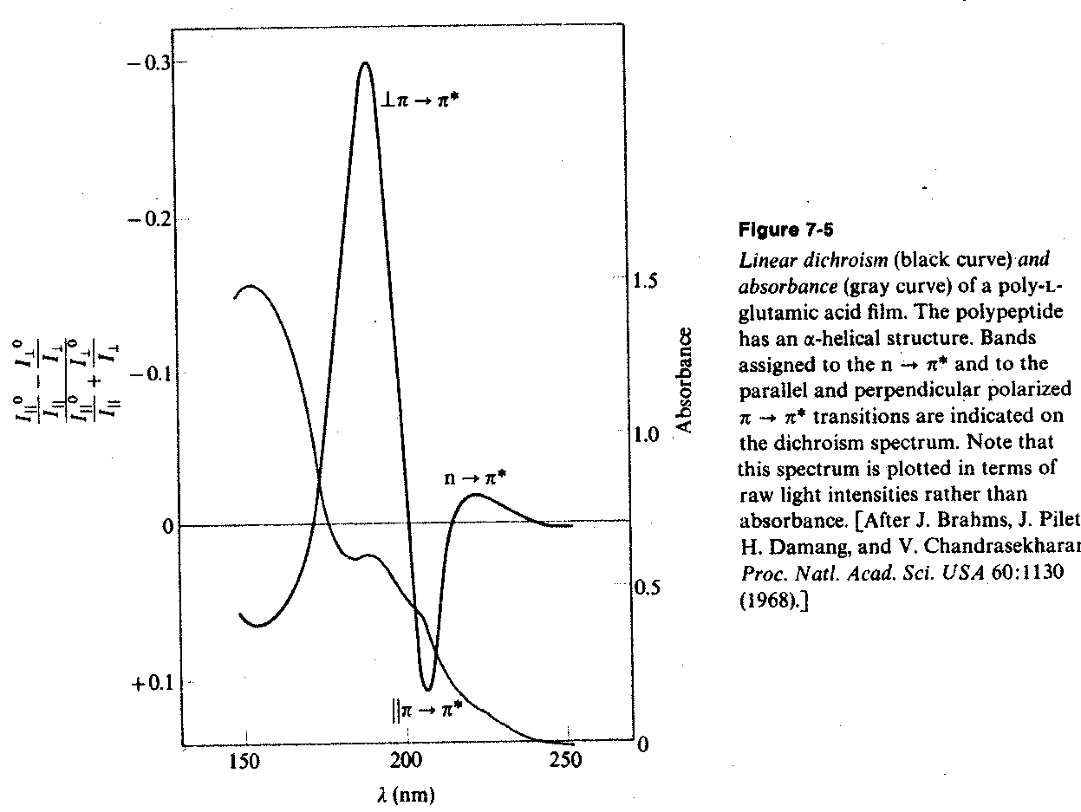
One can also observe linear dichroism in polypeptides. Again, orientation of the molecules is important. Figure 4 looks at the linear dichroism and absorbance of a poly-L-glutamic acid film. Starting from the right, looking at the red side of the UV absorption of the polypeptide, one sees weak absorbance at 250nm. The dichroic ratio for this component of the absorption is negative. Moving deeper into the UV one sees a band where the dichroic ratio is positive; absorbance was therefore stronger along the axis of the helix. Finally there is a strong absorbance where the dichroic ratio is again negative indicating that the strongest absorbance occurred when the radiation was polarized in the direction perpendicular to the axis of the helix.
Figure 4: Linear Dichroism and Absorbance
Figure 4: Linear Dichroism and Absorbance of a Poly-L-Glutamic Acid Film

If one could decompose this spectra, the presence of more than one absorption band it would be clearly indicated. Because one absorption band is associated with a particular dichroic ratio, the appearance of linear dichroism which changes as a function of wavelength (as seen above) indicates the presence of more than one absorption band.

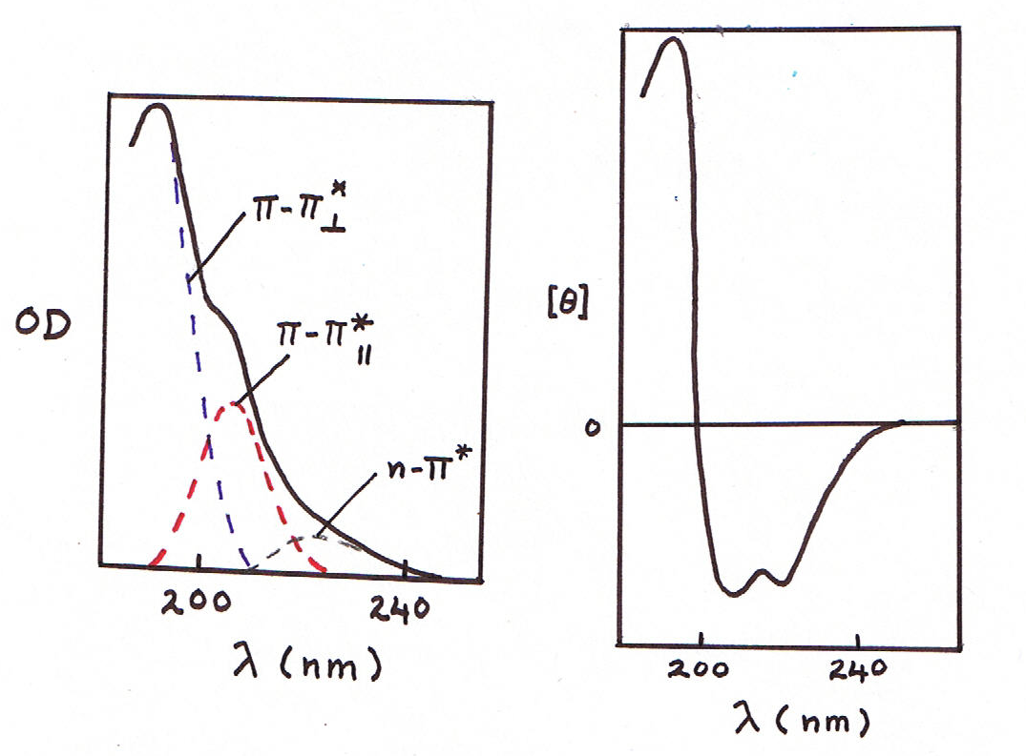
The same phenomenon is seen in figure 5 where which the transitions responsible for each absorption band are indicated. There is a weak absorption band on the red side of the UV absorbance of the polypeptide which corresponds to an n to Π* transition. Recall that n to Π* transitions are weak and that the electrons are excited, not in the plane as with Π to Π* transitions, but n electrons are promoted into a Π* orbital. It is therefore not surprising that the absorbance would be strongest in the direction perpendicular to the helix axis. Then one sees two bands associated with the Π to Π* transition. There is positive absorbance with a negative dichroism followed by a positive absorbance with a positive dichroism, indicating that the red component of the pair was polarized along the helix axis and the blue component was polarized perpendicular to the helix axis. The Π to Π* absorbance is split into two these components because of exciton splitting. Recall that exciton splitting is due to the interactions between adjacent absorbing chromophores, or in this case, adjacent peptide units in the alpha helix.
Figure 5: Exciton Splitting of α – Helical Peptide Absorption

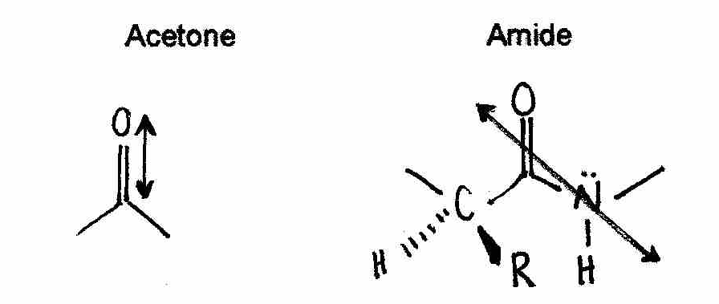
Dr. Galley showed the structure of an alpha helix (I didn’t include it here for the sake of simplicity but you can find it under 404 documents on the BUGS website). Each peptide unit has a changing dipole moment. Delocalization of the Π electrons onto the nitrogen creates an extended Π system. Thus, each peptide unit is planar and tilted in orientation. In addition, amides are poor bases because the lone pair electrons on the nitrogen are tied up in this extended Π system. One can compare the transition dipoles associated with acetone and an amide. For both molecules, the electron cloud tends to get swept out in the plane of the paper upon excitation. However R and H groups on the alpha carbon of the amide will cause the transition dipole to be twisted into or out of the plane because of their differing electronegativities. This gives the transition dipole moment a helical twist.

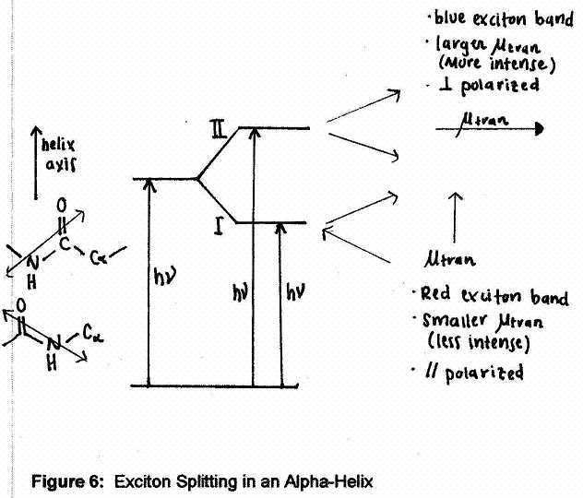
You can refer to the handouts Dr. Galley gave us on the first day or to your physchem II notes for the next part. The relevant sections are titled “exciton splitting in the alpha-helix” and “linear and circular dichroism measurements on the peptide absorption”. Figure 6 has been reproduced from the former section. The specific geometry and the transition dipole moments of adjacent residues in an alpha helix are shown. Because of the proximity and resultant interactions of the transition dipole moments it is impossible to excite one residue without simultaneously exciting the other. Therefore, in such a system, the components do not behave as independent units; they behave in a coupled fashion. The pair can be coupled in either an in-phase or an out-of-phase manner and what is observed on the absorption spectrum is a shoulder, indicating the presence of more than one component in the system.

Three important characteristics of these components must be noted:

1. There will be blue shifted and red shifted components. The out of phase state results in attractive interactions between adjacent transition dipoles and is thus lower in energy than the in phase state which results in repulsive interactions. Thus, in an alpha helix, unlike a random coil or a free amino acid in which there are no specific interactions, one sees splitting of the absorption spectrum into a high energy state (blue shifted) and a low energy state (red shifted).

2. The total intensity will be conserved but the intensities of the blue component and the red component will not necessarily be the same. One can sum the transition dipoles using vector addition to show the relative net transition dipoles of each component. The size of the dipole corresponds to the intensity of the absorption. For an alpha helix (figure 6) the blue exciton band is associated with a relatively large net transition dipole while the red exciton band is associated with a relatively small net transition dipole. That is why, in the corresponding spectrum, the blue component is more intense than the red component.

3. We can consider two simplified arrangements for the transition dipole moments of adjacent chromophores.
- A ‘card pack’ arrangement:
The in-phase component (blue) will have all of the intensity while the out of phase component (red) will have no intensity. For example, consider a sample of DNA in which the amount of acridine (or a similar DNA binding molecule) is increased. Eventually one no longer sees the strong binding due to intercalation but instead sees weak binding of the positively charged chromophore to the negatively charged DNA backbone. The absorption spectrum of acridine changes dramatically. At low concentrations in which the acridine intercalates into the DNA, one sees a small red shift due to the fact that the chromophore has entered a less polar environment. However, at higher concentrations, the acridine molecules tend to bind in a cooperative manner, stacking on top of one another in a ‘card pack’ arrangement. As a result of this cooperative binding one sees a large blue shift in the absorption spectrum.
- Lined up end to end: (This wasn’t in the lecture, but it is in the notes so I included it for completeness).
The in phase component (red) will now have all of the intensity and the out of phase component (blue) will have no intensity.

Intermediate arrangements (imagine opening up the “cards” in the card pack arrangement) can exist (as we have seen for the alpha helix) in which one sees both a red and a blue component. So, in each absorption spectrum exist three components: the red and blue components of the Π to Π* transition as well as the component corresponding to the n to Π* transition. Ideally, one should take into account the interaction between each chromophore and all of its neighbours but for our purposes this approach is sufficient.

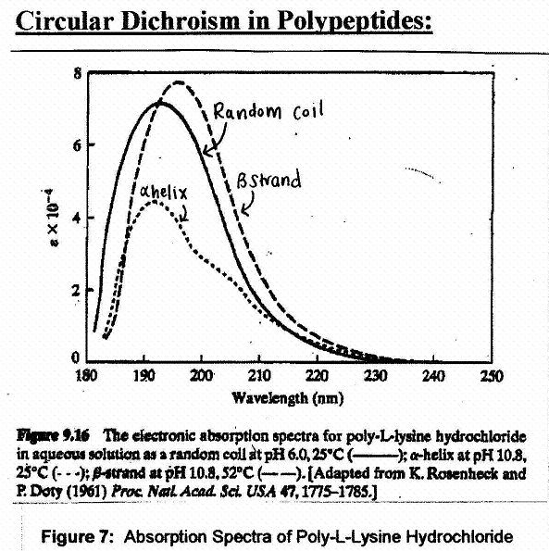
Figure 7 shows the electronic absorption spectra of poly-L-lysine hydrochloride in aqueous solution. A polypeptide chain can adopt an alpha helical, beta strand or random coil secondary structure depending on the pH and temperature conditions. Looking at the linear dichroism it is clear that the spectrum is composed of more than one component. However circular dichroism experiments are much more convincing. Looking at the circular dichroism observed for an alpha helical polypeptide (figure 8) one can clearly see three peaks. Starting at higher wavelengths and moving into the UV, one sees is a relatively strong negative peak which corresponds to the n to Π* transition. While the n to Π* transition is weak in the overall electronic absorption spectrum, it shows up strongly in circular dichroism experiments. Following the n to Π* peak are the two components produced by the exciton splitting which occurs in the Π to Π* transition. The two Π to Π* exciton states have preferential absorptions resulting in dichroic ratios of opposite sign.
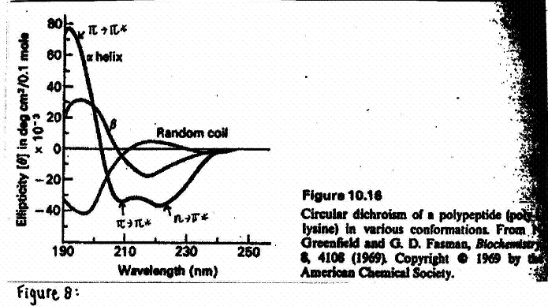
Note that the circular dichroism spectrum is obtained without aligning the sample. Also, one could convert the poly-L-lysine alpha helix to a beta sheet or a random coil and look at the absorption or the circular dichroism spectra again (Figures 7 and 8). The three secondary structures show very different spectra and can thus be easily distinguished. This technique can be used to identify the relative contributions of each of these secondary structures to the structure of a globular protein.
Figure 8: Circular Dicroism of a Polypeptide

Dr. Galley suggested that we look up some information on surface plasmon resonance for later discussion.

Figure 8: Cicular Dichroism

